Projectile Motion
Using Pasco Mini-Launcher
This lab experiment was taken from the manual published on line by Pasco® for the Mini-Launcher, ME-6825.
Equipment Needed

Plumb Bob
Paper, Carbon for use w/ Projectile Labs
Paper, White for use w/ Projectile Labs
Mini-Launcher, Pasco ME-6825 w/ Masking Tape
Safety Goggles
Tape Measure, 5m Stanley 33-158

Figure 1 Typical Setup
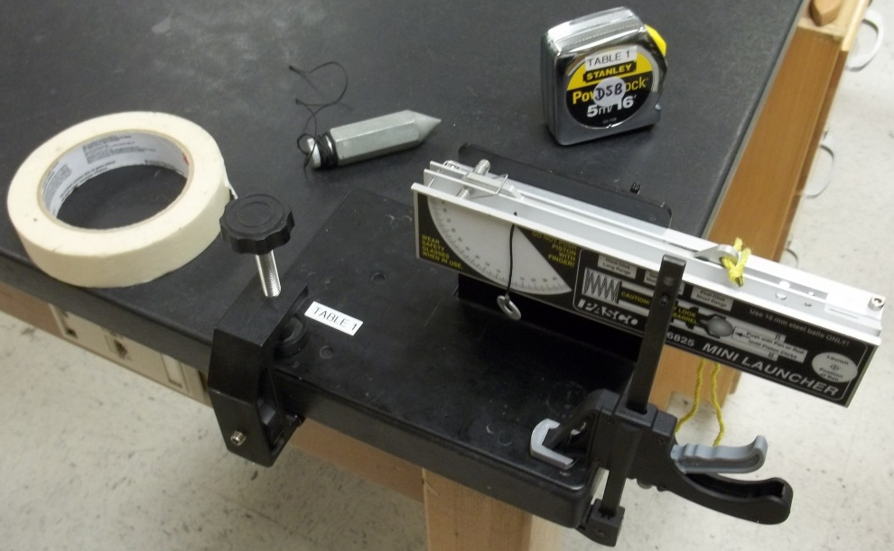
Purpose
The purpose of this experiment is to predict and verify the range of a ball launched at an angle. The initial velocity of the ball is determined by shooting it horizontally and measuring the range and the height of the Launcher.
Theory
To predict where a ball will land on the floor when it is shot off a table at an angle, it is necessary to first determine the initial speed (muzzle velocity) of the ball. This can be determined by launching the ball horizontally off the table and measuring the vertical and horizontal distances through which the ball travels. Then the initial velocity can be used to calculate where the ball will land when the ball is shot at an angle.
INITIAL HORIZONTAL VELOCITY:
For a ball launched horizontally off a table with an initial speed, , the horizontal distance travelled by the ball is given by , where is the time the ball is in the air. Air friction is assumed to be negligible.
The vertical distance the ball drops in time is given by 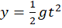.
The initial velocity of the ball can be determined by measuring and . The time of flight of the ball can be found using:
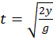
and then the initial velocity can be found by using 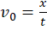.
INITIAL VELOCITY AT AN ANGLE:
To predict the range, , of the ball when it is launched with an initial velocity at an angle , above the horizontal, first predict the time of flight using the equation for the vertical motion:
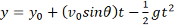
Setup
- Clamp the Mini-Launcher near one end of a sturdy table as shown in Figure 2
- Adjust the angle of the Mini-Launcher to zero degrees so the ball will be shot horizontally.
Figure 2
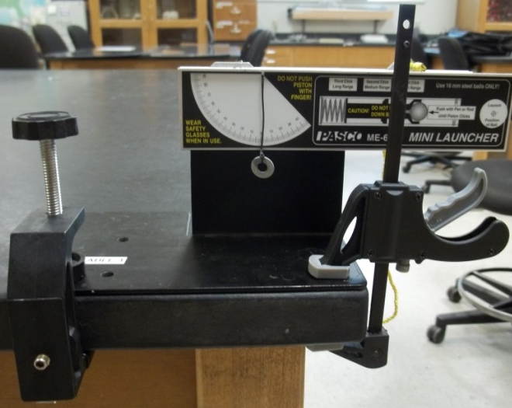
Procedure Part A: Determining the Initial Velocity of the Ball
- Put the ball into the Mini-Launcher and cock it to the first position. Fire one shot to locate where the ball hits the floor. At this position, tape of piece of white paper to the floor. Place a piece of carbon paper (carbon-side down) on top of the white paper. Do not put tape on the carbon paper. It is not necessary. On subsequent shots, the ball will leave a mark on the white paper.
- Fire ten shots.
- Measure the vertical distance, , from the bottom of the ball as it leaves the barrel (this position is marked on the side of the barrel) to the floor. Record this distance in Table 1.1.
- Use a plumb bob to find the point on the floor that is directly beneath the release point on the barrel. Measure the horizontal distance along the floor from the release point to each dot on the paper. Record in the Table 1.1.
- Find the average distance, , for all of the shots.
- Using the vertical distance, calculate the time of flight.
- Using the time of flight and average , calculate the initial velocity.
Table 1.1: Determining the Initial Velocity.

Vertical distance =__________
Calculated time of flight =__________
Initial Velocity =__________

Trial Number | Distance
1
2
3
4
5
6
7
8
9
10
Total Distance
Average Distance

Procedure Part B: Predicting the Range of a Ball Shot at an Angle
- Adjust the Mini-Launcher to launch at an angle between 20 and 60 degrees above the horizontal. Record this angle in Table 1.2.
- Using the initial velocity and vertical distance found in Part A of this experiment, calculate the new time of flight and the new horizontal range for a projectile launched at the new angle. Record in Table 1.2.
- Draw a line across the middle of a white piece of paper and tape the paper on the floor so the line is at the predicted horizontal distance from the Mini-Launcher. Cover the paper with carbon paper.
- Shoot the ball ten times.
- Measure the ten distances and take the average. Record in Table 1.2.
Analysis
- Calculate the Average Distance and record in Table 1.2.
- Calculate and record the percent difference between the predicted value and the experimental value.
Table 1.2: Confirming the Predicted Range

Angle above horizontal = __________
Calculated time of flight = __________
Predicted range = __________
Experimental range = __________
% difference = __________

Trial Number | Distance
1
2
3
4
5
6
7
8
9
10
Total Distance
Average Distance

